Lesson: The Renaissance

Aim: What is the Renaissance?

Why did it begin in Italy?

Do Now: Read the following passage and list 3 reasons why the Renaissance started in Italy?

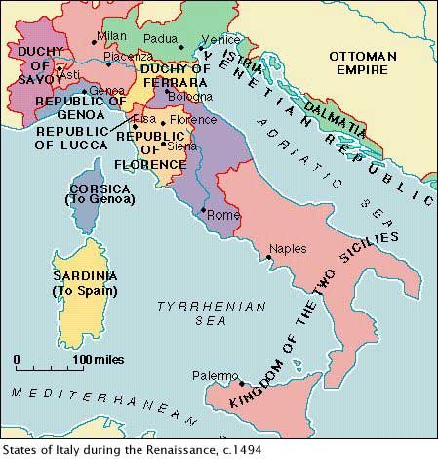

Italy had three advantages that made it the birthplace of the Renaissance. First, overseas trade had led to the growth of large city-states in northern Italy. The region also had many sizable towns. Thus, northern Italy was urban while the rest of Europe was still mostly rural. Since cities are often places where people exchange ideas, they were an ideal breeding ground for an intellectual revolution.

Second, a wealthy merchant class developed in, each Italian city-state. In the 1300s, the bubonic plague struck these cities hard, killing up to 60 percent of the population. This brought economic changes. Because there were fewer laborers, survivors could demand higher wages. With few opportunities to expand business, merchants began to pursue other interests, such as art.

Third, Renaissance scholars looked down on the art and literature of the Middle Ages. Instead, they wanted to return to the learning of the Greeks and Romans. They achieved this in several ways. The artists, architects, and scholars of Italy drew inspiration from the ruins of Rome that surrounded them. Scholars also studied ancient Latin manuscripts that had been preserved in monasteries and Greek manuscripts that had been brought to Rome when Christian scholars fled Constantinople as it fell to the Turks in 1453.

**Reasons why the Renaissance started in Italy**

1. **Italy is the center of trade and manufacturing**
2. **Merchants began pursuing other interests, such as the arts**
3. **Scholars brought back the Roman and Greek culture**

**Humanism Emerges**

Books also helped to spread awareness of a new philosophy that emerged when Renaissance scholars known as humanists returned to the works of ancient writers. Previously, during the Middle Ages, scholars had been guided by the teachings of the church, and people had concerned themselves with actions leading to heavenly rewards. The writings of ancient, pagan Greece and Rome, called the "classics," had been greatly ignored. To study the classics, humanists learned to read Greek and ancient Latin, and they sought out manuscripts that had lain undisturbed for nearly 2,000 years.

The humanists rediscovered writings on scientific matters, government, rhetoric, philosophy, and art. They were influenced by the knowledge of these ancient civilizations and by the emphasis placed on man, his intellect, and his life on Earth.

**The Humanist Philosophy**

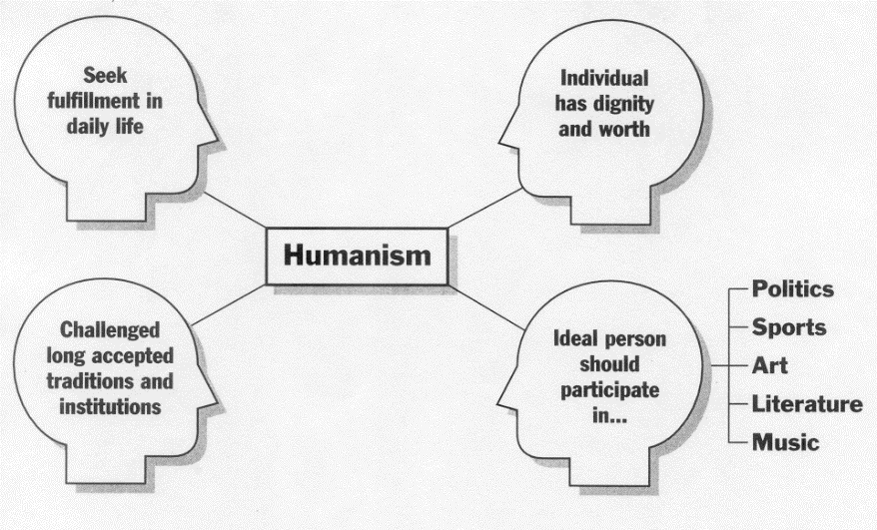The new interest in secular life led to beliefs about education and society that came from Greece and Rome. The secular, humanist idea held that the church should not rule civic matters, but should guide only spiritual matters. The church disdained the accumulation of wealth and worldly goods, supported a strong but limited education, and believed that moral and ethical behavior was dictated by scripture. Humanists, however, believed that wealth enabled them to do fine, noble deeds, that good citizens needed a good, well-rounded education (such as that advocated by the Greeks and Romans), and that moral and ethical issues were related more to secular society than to spiritual concerns.

1. Define Secularism in your own words.

**Secular is concerned with more worldly issues than spiritual matters**

1. Define Humanism in your own words.

**A movement in which thinkers studied classical texts (Greco-Roman) and focused on human potential and achievements.**

1. How did each concept differ from the attitudes and ideas of the Middle Ages?

**During the Middle Ages, scholars had been guided by the teachings of the church, and people had concerned themselves with actions leading to salvation.**

**The Middle Ages vs. the Renaissance**

How did the Renaissance differ from the Middle Ages?

|  |  |  |
| --- | --- | --- |
| **BELIEF** | **MIDDLE AGES (500-1300)** | **Renaissance (1350-1600)** |
| **MAN** | * Most people tied to land * Feudalism and manorialism | - Middle class emerges  - Leisure time allows for reading,  music, studying |
| **CHURCH** | * center of society * people concerned with heaven and salvation | -Church should guide only spiritual matters |
| **EDUCATION** | * Books costly – education rare – only clergy was educated * Most books written in Latin | - Printing press made books more available  - Books written in the vernacular  -More people were educated |
| **ON LIFE** | * Focus on religious issues and salvation | - Focus on worldly life –  developing talents |
| **ART** | * Mosaics – all biblical figures * Icons * Anonymous artists | -More realistic, use of expression and emotions  -Use of perspective  - Study of human anatomy  -Artists took credit for work |

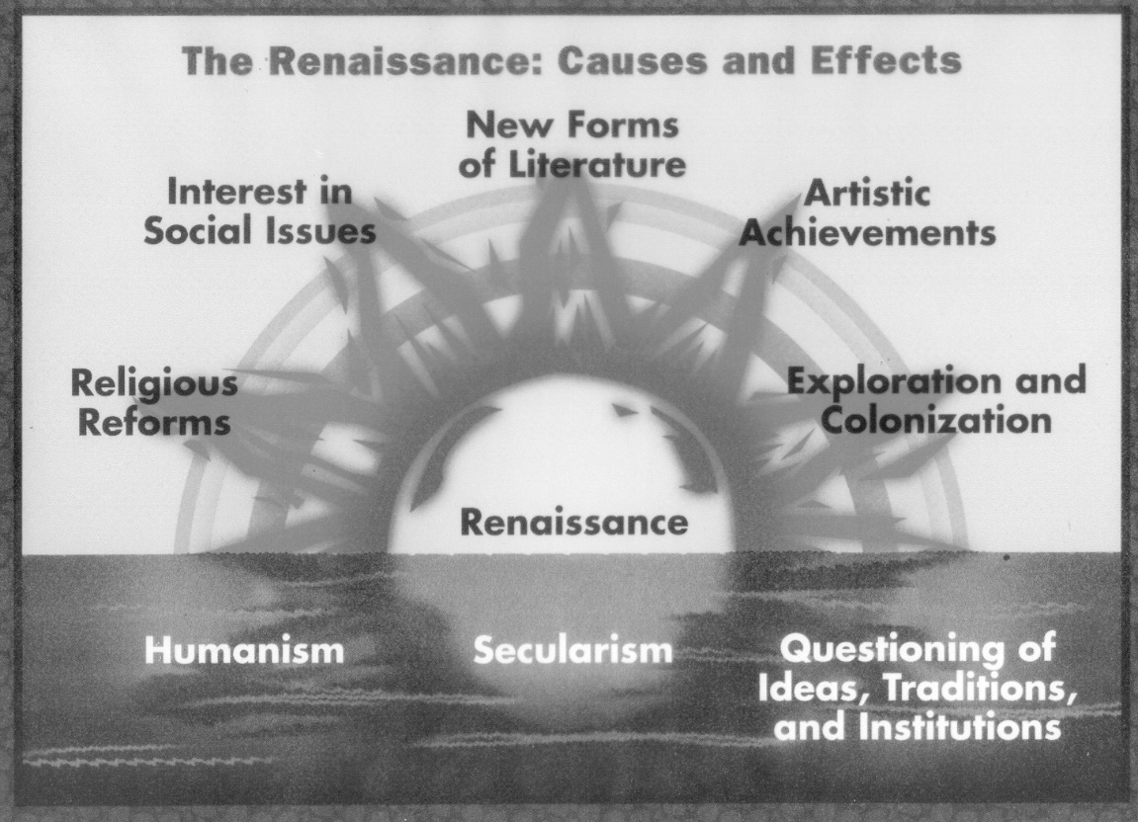

1. Why do you think that the Renaissance is shown as a rising sun?

**Renaissance is a rebirth, new beginnings.**

1. How did Humanism and Secularism change European society?

**During the Middle Ages, philosophers and writers wondered about life after death. The Renaissance humanists focused on life in the present. They emphasized individual achievements, believed education sparks creativity, studied grammar, poetry, history, literature, philosophy, and many more subjects.**

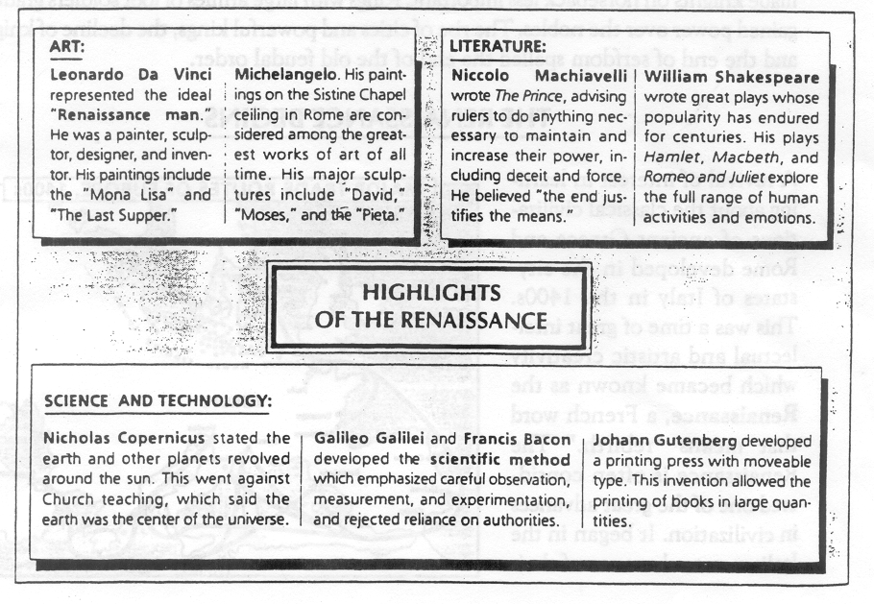

**How did the social system change during the Renaissance?**

Create your own Renaissance social hierarchy using the information provided. Be sure to explain why you placed certain social classes where you did.

Renaissance Society

The Italian city-states fashioned a new social order in which wealth and ability mattered more than aristocratic titles and ownership of land. Wealthy merchants and bakers replaced the landed nobility and clergy as the most powerful social and political group. Shopkeepers and artisans (A skilled manual worker; a craftsperson) ranked below the wealthy merchants, forming a moderately prosperous middle class that employed large numbers of poor workers. Most of these workers (the majority of town dwellers) came from the countryside to urban areas. At the bottom of the social order were the peasants who worked on the country estates of the upper class.

Although Renaissance society was divided into three estates, or social classes, much like the Middle Ages, there were many changes. Serfdom was in decline as the labor owed by a peasant to the lords was converted into rent on land paid in money. There was also growing middle class due to increased prosperity in the urban city-states and specialized labor.

Peasants and townspeople made up the majority of society, but their ranks became more diverse. Townspeople were divided into three classes-patricians, burghers (A member of the mercantile/middle class), and the poor and unemployed.

Nobles dominated society although they were only a small percentage of the population. They held important political posts and served as advisors to the king.

Patricians were wealthy industrialists, bankers, and merchants. Beneath them were the burghers: shopkeepers, artisans, and guild members who provided services for the town.

Create your own Renaissance social hierarchy using the information provided. Be sure to explain why you placed certain social classes where you did.

**Merchants-were wealthy merchants who held most of the po**

**power.**

**Artisans- were below the merchants, they were the**

**Skilled manual workers a craftsman.**

**Middle class population.**

**Peasants and townspeople made up the majority**

**of society- lower class**

Renaissance writers introduced the idea that all educated people were expected to create art. In fact, the ideal individual strove to master almost every area of study. A man who excelled in many fields was praised as a "universal man." Later ages called such people "**Renaissance men**." To learn how to become such a person, Renaissance men could turn to *The Courtier* (1528), a book by Baldassare Castiglione. According to the book, a young man should be charming, witty, and well educated in the classics. The book advised upper-class women to know the classics and be charming. Yet women were not expected to seek fame. They were expected to inspire art but rarely to create it.

**David**

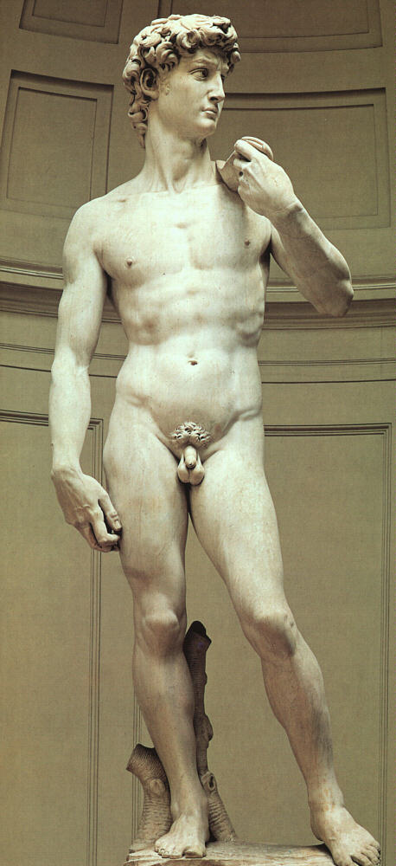

**Michelangelo Buonarroti**

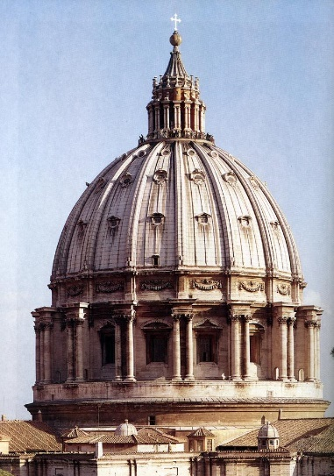The story of Creation is told in the Book of Genesis in the Bible. It is told again, in pictures, on the ceiling of the Sistine Chapel in Rome. This series of beautiful paintings is the work of an Italian artist, Michelangelo Buonarroti (1475- 1564). Michelangelo is even more famous as a sculptor than as a painter. He created huge and powerful statues of Moses and David. Born near Florence, the 13-year-old Michelangelo was apprenticed to the painter Ghirlandaio. The boy soon turned to sculpture after seeing the marble statues in the garden of the Medici palace. **Lorenzo di Medici**, ruler of Florence and **patron of the arts** (**Many nobles, merchants and bankers used their wealth to encourage the development of art literature and science.**), was impressed by Michelangelo's ability and took the boy into his household. For several years Michelangelo studied sculpture in the school begun by **Medici**. Michelangelo, stubborn, moody, and short-tempered, was devoted to his art. His talent developed quickly. He painted, sculpted, and wrote poetry. As an architect, Michelangelo designed many buildings and monuments, including the great dome of St. Peter's. He was also active in the politics of the day. Among Michelangelo's patrons were the most powerful men in Europe. Chief among them was Pope Julius 11. It was for Julius that Michelangelo painted the Sistine Chapel. Michelangelo painted the ceiling while lying on his back on a scaffold high above the chapel floor. The ceiling was an area of 10,000 square feet. It took Michelangelo four years to complete the paintings. Michelangelo died at the age of 89, a Renaissance man.

1. What is a Renaissance man?

**A man who strove to master and excelled in many fields of study.**

2. What is a patron? How did they encourage the development of the arts?

**A person who supports artists, especially financially. Patrons used their wealth to encourage the development of art, literature, and science.**

3. Describe three examples that prove Michelangelo was a Renaissance man?

**He was educated, an artist, painter, and writer.**

This activity will give you the chance to pretend that you are a person living during the Renaissance.

Pretend that you are a sailor living during the Italian Renaissance. You live in Northern Europe and have not yet been exposed to the ideas of the Renaissance. During a trip to Italy you decide that when you arrive in port, you will take a trip to nearby Florence. While you are there, you become so inspired by what is going on that you decide to write a brief journal entry to a friend back home.

Using what we have learned today, as well as the pictures and the handouts, describe what life is like in Renaissance Italy.

What are you seeing all around you? What strikes you as the most important changes in the society? What is life like for the people living there? What are the new ideas these people are discussing? Make sure to include your overall impressions of what it is that is going on in Italy.

In your paragraph describe what you see in Florence, Italy (remember life is different from the middle ages).

Be sure to discuss that there is the arts, music, literature, science, etc,,There are merchants, scholars, and artisans.